**LAYERING OF BANK ACCOUNT**

**ASSIGNMENT 1**

**ABSTRACT:** This is the second stage where the origins of the funds are concealed by moving them around in a series of complex bank transfers or financial transactions. Out of the various techniques of layering, the most common is to make electronic transfers between different jurisdictions and through offshore accounts. For instance, the criminal may wire the proceeds to a corporation in an overseas island where the money trail doesn’t end because the same corporation can be owned by a trust on another island.

**REQUIREMENTS ANALYSIS:**

LIST OF TABLES:

* Branch
* Account
* Customer

List of Attributes with their Domain Types:

BRANCH:

* bid number(10)
* bname varchar(20)
* blocation varchar(20)

ACCOUNT:

* bid number
* acc_no number
* acc_type varchar2(20)
* balance number(5)

CUSTOMER:

* cid number
* cname varchar2(20)
* address varchar2(20)
* ph_no number(10)
* aadhar_num number(12)

**DESIGN**

**ENTITY RELATIONSHIP DIAGRAM**

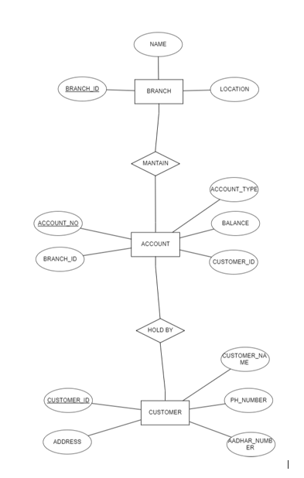

**DDL OPERATIONS:**

create table branch(

bid number(10),

bname varchar(20),

blocation varchar(20));

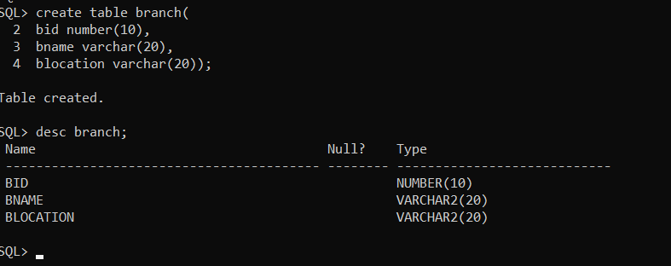

**SETTING BID AS PRIMARY KEY:**

alter table branch add primary key(bid);

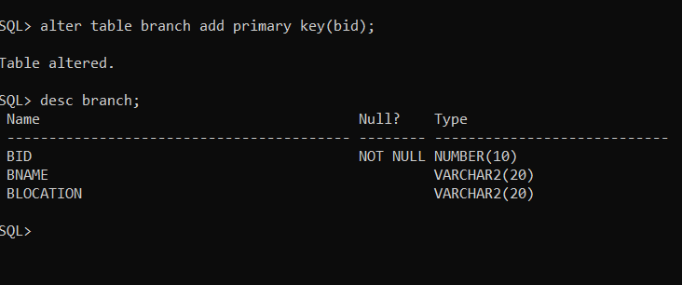

create table account(

bid number,

acc_no number,

acc_type varchar2(20),

balance number(5),

cid number(5));

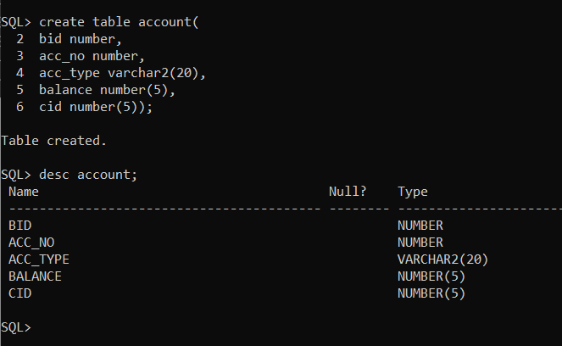

**SETTING CID AS PRIMARY KEY:**

alter table account add primary key(cid);

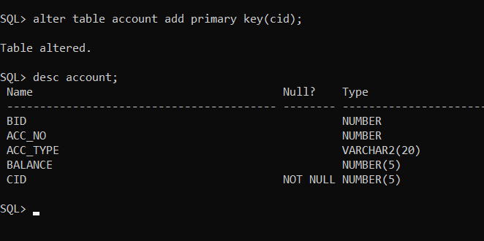

create table customer(

cid number,

cname varchar2(20),

address varchar2(20),

ph_no number(10),

aadhar_num number(12));

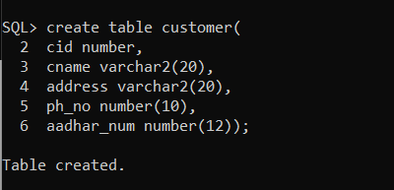

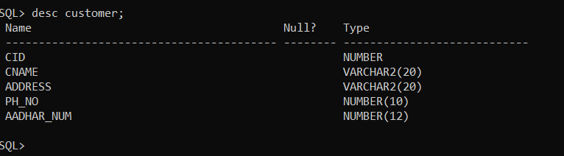

**SETTING CID AS FOREIGN KEY:**

alter table customer add foreign key(cid) references account;

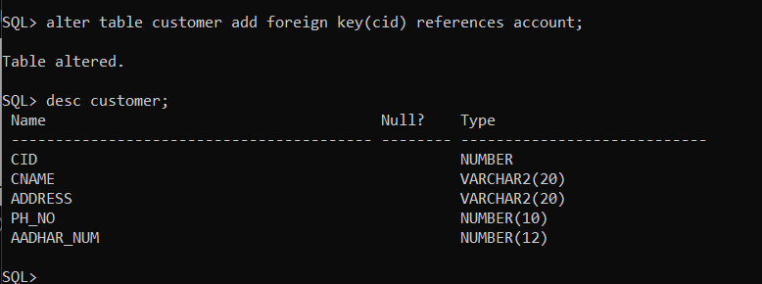

**Inserting Values into Branch Table:**

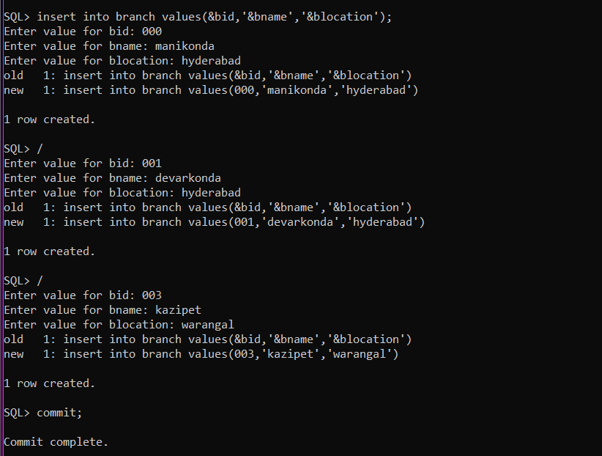

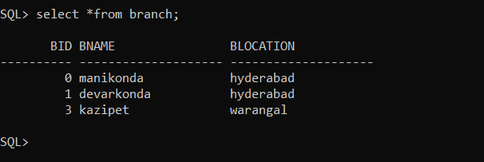

**Inserting Values into Account Table:**

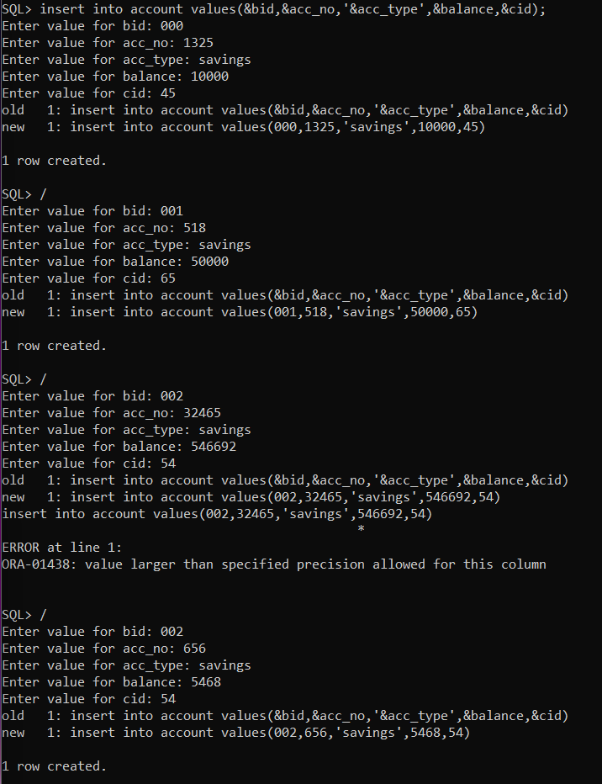

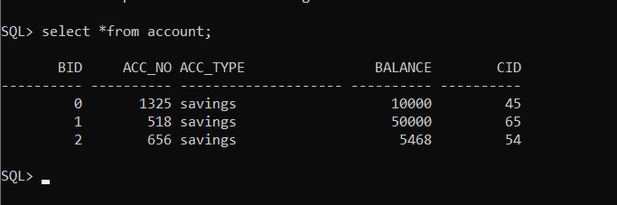

**Inserting Values into Customer Table:**

